目录

2 Write a Store Factory Using Openzeppelin 1

1coding 2

2 Manual test 3

3 truffle test 3

# 2 Write a Store Factory Using Openzeppelin

Github.com/onebit256/proxy

## 1coding

Ganache-cli -m ‘’

Truffle init

Npm init

Npm i @openzeppelin/upgrades@2.8.0

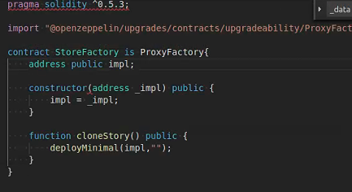

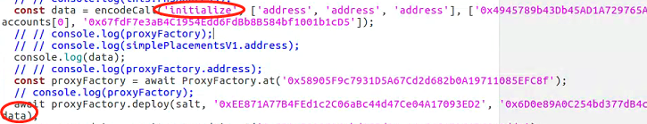

As there is no init function

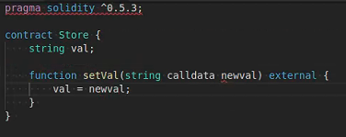

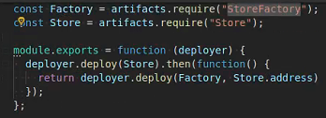

## 2 Manual test

Const sf = await StoreFactory.deployed()

Sf.impl()

Networks

Sf.clonestore()

Sf.getPastEvents()

Sf.clonestore()

Sf.clonestore()

St1 = Store.at(‘’)

St1.setVal(“ss”)

St1.val()

## 3 truffle test